Ticket Manual

*This manual explains how to navigate throughout the ticket program and will show you how to open and close tickets, set up users, send emails, and FAQ*

1. First step in creating a ticket is creating the user. This is for putting down the customers information and making them their own account. It will look similar to this:

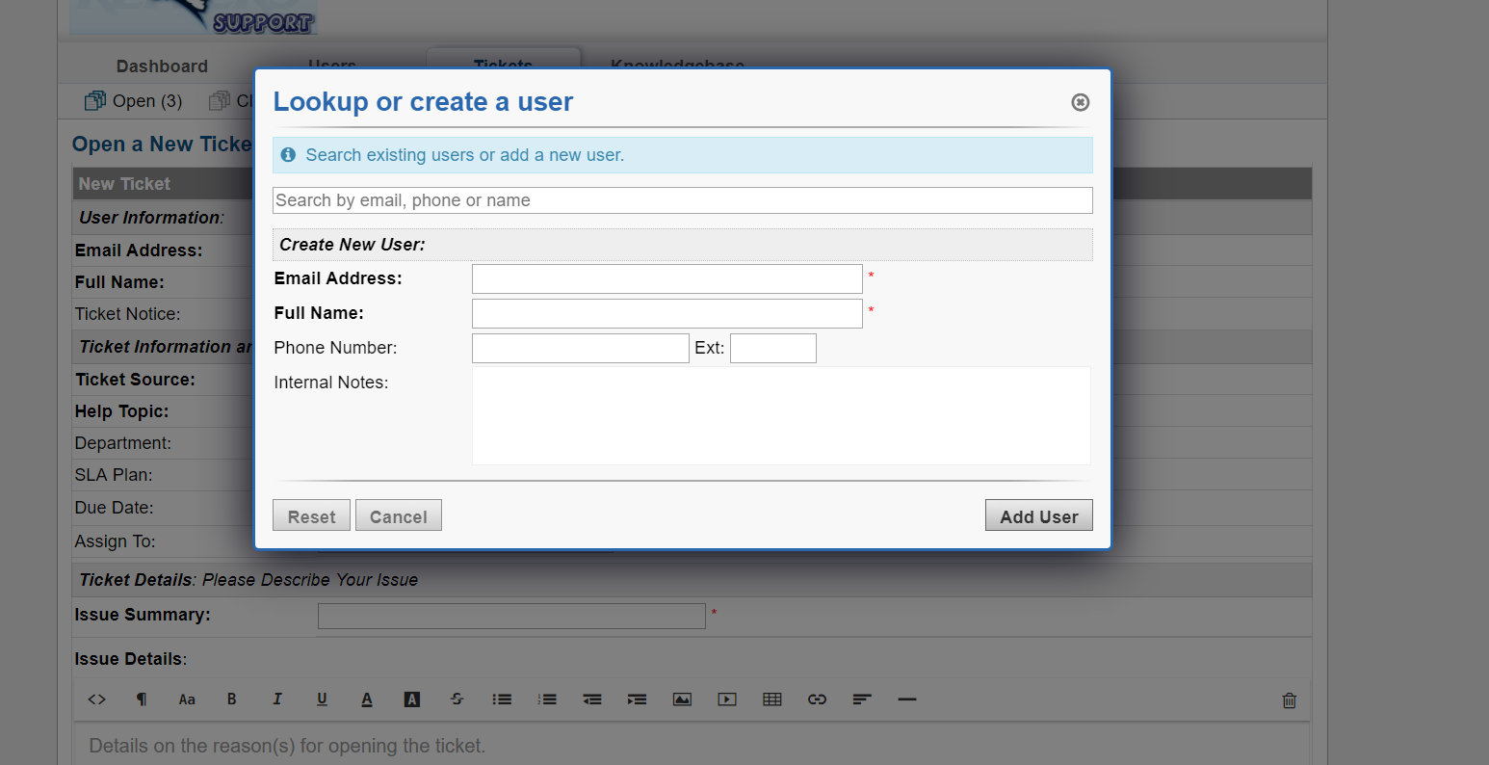

1. After you have the user created you have to create the ticket and fill out all of the information. This consists of putting in their problem, assigning it to a certain department, summarizing the issue, it will look similar to this:

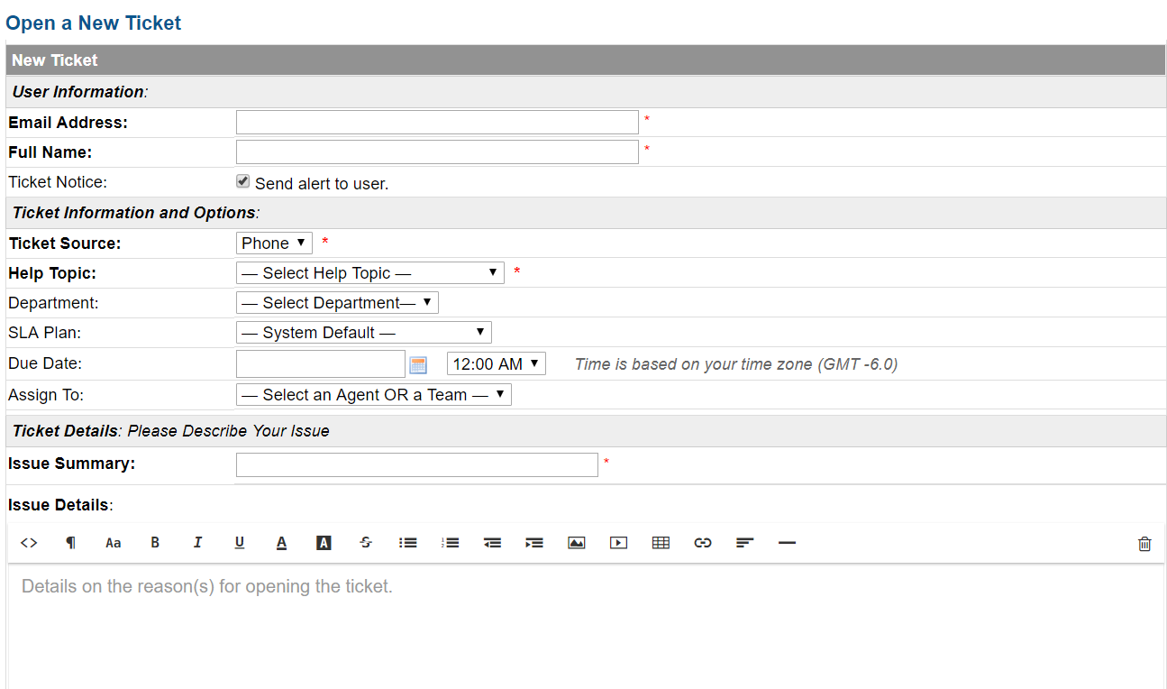

1. Once the ticket is finished you will need to email the customer and notify them that their machine is done being worked on. This is done by clicking on the ticket and going to the bottom and going to the area that looks like this:

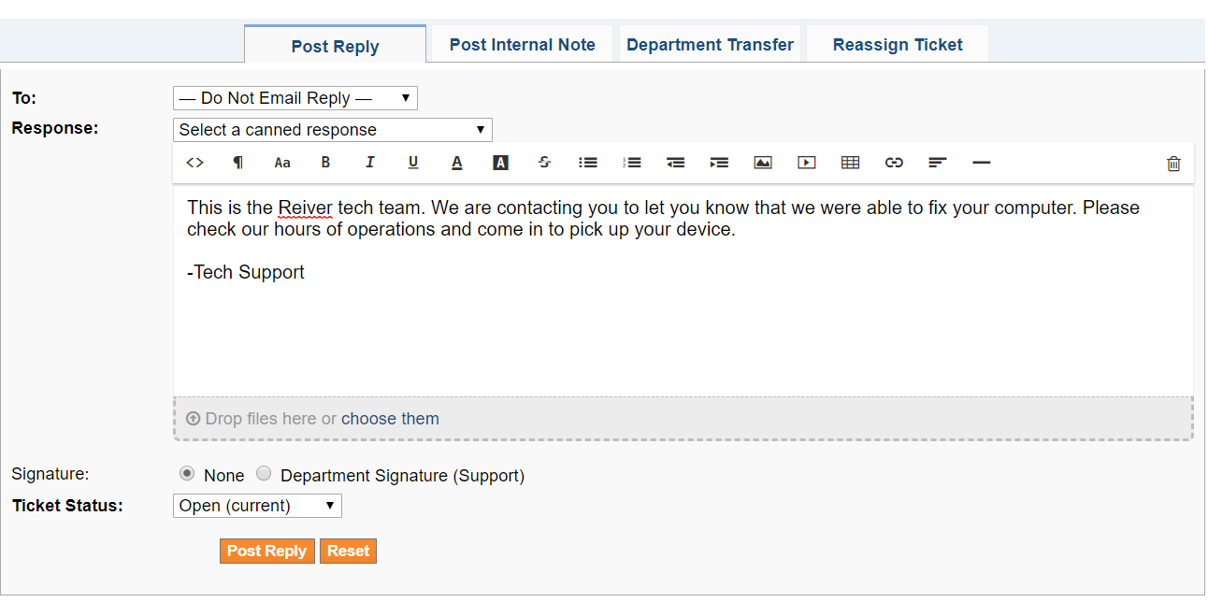

You can write your own response or select a canned one, the one used in the picture is a closing canned response.

1. Once you have your email written you will have to change the ticket to resolved in the system. This is done by going to the “Ticket Status” drop down box at the bottom of your screen. It will look like this:



You should mark it as Resolved at first, but once it is picked up by the owner you can change it to Closed.

1. You may also want to add FAQ to your company website. This can be done and should be split up into different sections. These sections could be tutorials, hardware replacement website links, virus removal software, etc. The FAQ section will look something similar to this:

